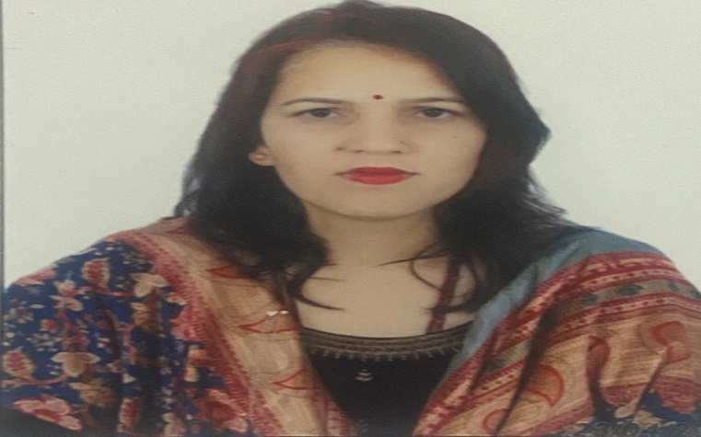

**Mrs. Saroj**

**Assistant professor in Nimbus School of Education**

**Area**

Primary Area: Education

Secondary Area: English

**Contact**

Email: sarojkhanna86@gmail.com

Phone: +91-7895249620

**Education**

* M.Ed. from H.N.B. Garhwal University.
* B.Ed. from H.N.B. Garhwal University.
* Post Graduate (M.A. English), Sri dev Suman University.

**Teaching**

* Education
* English

**Academic Experience**

Teacher, Blooming Public school may 2015 onwards

Teacher, Room to read, May 2018, onwards

Faculty Member, Uttaranchal college of Education, January 2022, onwards

Faculty Member, Nimbus School of Education, _________________onwards

**Professional Experience**

Nimbus School of Education

Nimbus Academy of Management